|  |  |  |  |  |
| --- | --- | --- | --- | --- |
|  |  | | |  |
|  |  | | |  |
|  | Driver Focused Mode  <<Feature>>  (F001212) | | |  |
|  |  | | |  |
| Document Type | **Feature Document (FD)** | | |  |
| Template Version | **6.1a / FFSD 7.1** | | |  |
| SysML Report Template Version | **O Beta (9/27/2019)** | | |  |
| Document ID | **ffst01.10_featuredocument_sysmlreporttemplate** | | |  |
| Document Location |  | | |  |
| Document Owner | **<Ruochen Yang, ryang30>;**  **<Mohamed Baghdadi, mbaghdad>;**  **<Aravindan Balakrishnan, abalak10>**  **<Halim Wijaya, hwijaya>**  **<Erika Moctezuma, emoctezu>**  **<Daniel Garcia, cgarc176>** | | |  |
| Document Revision | **FD0** | | |  |
| Document Status | **Draft** | | |  |
| Date Issued | **2021/03/09** | | |  |
| Date Revised | **2021/03/09** | | |  |
| Document Classification | GIS1 Item Number: | **27.60/35** | |  |
| GIS2 Classification: | **Confidential** | |
|  | | | | |
|  | | | | |
| Document Approval | | | | |
| Person | Role | | Email Confirmation | Date |
|  |  | |  |  |
|  |  | |  |  |

**Auto-Generated by MagicDraw**

Printed Copies Are Uncontrolled

# Disclaimer

**This document contains Ford Motor Company Confidential information. Disclosure of the information contained in any portion of this document is not permitted without the expressed, written consent of a duly authorized representative of Ford Motor Company, Dearborn, Michigan, U.S.A.**

**Copyright, Ó 2016 Ford Motor Company**

This document contains information developed and accumulated by and for FORD MOTOR COMPANY. As such, it is a proprietary document, which, if disseminated to unauthorized persons, would provide others with restricted information, data, or procedures not otherwise available, exposing the FORD MOTOR COMPANY to potential harm.

Employees and suppliers having custody of this specification or authorized to use it must be cognizant of its proprietary nature and ensure that the information herein is not made available to unauthorized persons.

FORD MOTOR COMPANY reserves the right to protect this work as an unpublished copyrighted work in the event of an inadvertent or deliberate unauthorized publication. FORD MOTOR COMPANY also reserves its rights under copyright laws to protect this work as a published work.

This document or portions thereof shall not be distributed outside FORD MOTOR COMPANY without prior written consent. Refer all questions concerning disclosure to the author(s) or to any duly authorized representative of Ford Motor Company.

# Contents

1.1.2 Decomposition of Functional Safety Requirement 13

Disclaimer 22

Contents 23

2 Introduction 26

2.1 Document Purpose 26

2.2 Document Scope 26

2.3 Document Audience 26

2.3.1 Stakeholder List 26

2.4 Document Organization 26

2.4.1 Document Context 26

2.4.2 Document Structure 27

2.5 Document Conventions 27

2.5.1 Requirements Templates 27

3 Feature Overview 28

3.1 Purpose and Description of Feature 28

3.2 Feature Variants 28

3.2.1 Regions & Markets 29

3.3 Input Requirements 29

3.3.1 Legal Requirements 30

3.3.2 Trustmark Requirements 30

3.3.3 Industry Standards 30

3.3.4 Attribute Requirements 30

3.4 Lessons Learned 30

3.5 Assumptions 31

3.6 References 31

3.6.1 Ford Documents 32

3.6.2 External Documents and Publications 32

3.7 Glossary 33

3.7.1 Parameters / Values 33

4 Feature Context 34

4.1 Feature Context Diagram 34

4.2 List of Influences 34

5 Feature Modeling 36

5.1 Operation Modes and States 36

5.2 Use Cases 38

5.2.1 Use Case Diagram 38

5.2.2 Actors 39

5.2.3 Use Case Descriptions 39

5.3 Driving and Operation Scenarios 43

5.4 Decision Tables 45

6 Feature Requirements 46

6.1 Functional Requirements 46

6.1.1 Error Handling 47

6.2 Non-Functional Requirements 47

6.2.1 Safety 47

6.2.2 Security 47

6.2.3 Reliability 47

6.3 HMI Requirements 47

6.4 Other Requirements 48

6.4.1 Design Requirements 48

6.4.2 Manufacturing Requirements 48

6.4.3 Service Requirements 48

6.4.4 After Sales Requirements 48

6.4.5 Process Requirements 48

6.4.6 Uncategorized Requirements 49

7 Functional Safety 50

7.1 System Behaviors for HARA 50

7.2 Safety Assumptions 50

7.3 Safety Goals 51

7.4 Functional Safety Requirements 53

7.4.1 Safety Goal: 53

7.4.2 Derivation of Functional Safety Requirements on Assumptions 55

7.5 ASIL Decomposition of Functional Safety Requirements 56

8 Architecture 57

8.1 Functional Architecture 57

8.1.1 List of Functions 57

8.2 Logical Architecture 58

8.2.1 Logical Interfaces 59

9 Open Concerns 61

10 Revision History 62

11 Appendix 63

11.1 Definitions 63

11.2 Abbreviations 63

**List of Figures**

Figure 1. 12

Figure 2: 28

Figure 3: - 28

Figure 4: 34

Figure 5: 36

Figure 6: 38

Figure 7:  55

Figure 8: 57

Figure 9: 58

**List of Tables**

Table 1: Features described in this FD 26

Table 2: Feature Variants 29

Table 3: Regions & Markets 29

Table 4: Ford internal Documents 32

Table 5: Ford internal Documents *(not specified in SysML model)* 32

Table 6: External documents and publications 32

Table 7: External documents and publications *(not specified in SysML model)* 33

Table 8: Parameters / Values used in this document *(Not supported by MagicDraw report generation)* 33

Table 9: List of Influences 35

Table 10: Operation Modes and States on 36

Table 11: Transitions between Operation Modes and States on 38

Table 12: List of Actors 39

Table 13: System Behaviors for HARA 50

Table 14: Functional Safety Assumptions 51

Table 15: Functional Safety Goals 53

Table 16: List of Functions 58

Table 17: List of Functions on 58

Table 18: Feature Interactions 59

Table 19: Feature Interactions on 59

Table 20: Open Concerns *(Not supported by MagicDraw report generation)* 61

Table 21: Definitions used in this document 63

Table 22: Abbreviations used in this document 64

# Introduction

## Document Purpose

A Feature Document (FD) document specifies **what** the feature shall do and how it shall behave from customer perspective. It should also provide reasoning and background **why** we have the feature in the vehicle.

The FD also serves as an Item Definition as defined by ISO26262 for those features, which follow the Ford Functional Safety process.

To get more information about the concept of feature, function and component level abstraction refer to the [Ford RE Wiki](http://wiki.ford.com/display/RequirementsEngineering/Requirements+Engineering+for+SW+Enabled+Features). For details on the Ford Functional Safety (ISO26262) process refer to the [Ford Functional Safety Sharepoint](https://pd3.spt.ford.com/sites/GlobalFunctionalSafety/Pages/default.aspx).

## Document Scope

This Feature Document (FD) specifies the following features:

|  |  |  |  |
| --- | --- | --- | --- |
| **Feature ID** | **Feature Name** | **Owner** | **Reference** |
| F001212 | Driver Focused Mode  (Program(s): V710 (DFM); Ford Transit Van  tentatively V702 (DFM Lite)  ) | <Ruochen Yang, ryang30>;  <Mohamed Baghdadi, mbaghdad>;  <Aravindan Balakrishnan, abalak10>  <Halim Wijaya, hwijaya>  <Erika Moctezuma, emoctezu>  <Daniel Garcia, cgarc176> |  |

Table 1: Features described in this FD

## Document Audience

The FD is written by the feature owner of <Ruochen Yang, ryang30>;

<Mohamed Baghdadi, mbaghdad>;

<Aravindan Balakrishnan, abalak10>

<Halim Wijaya, hwijaya>

<Erika Moctezuma, emoctezu>

<Daniel Garcia, cgarc176>

. All Stakeholders, i.e., all people who have a valid interest in the feature should read and, if possible, review the FD. It needs to be guaranteed, that all stakeholders have access to the currently valid version of the FD.

### Stakeholder List

For the latest list of stakeholder of the feature and their influence refer to <Put VSEM Link here>.

|  |  |  |  |  |
| --- | --- | --- | --- | --- |
| **Name** | **CDSID** | **Contact Info** | **Role** | **Stakeholder Group** |
| Erika Moktezuma |  |  | Modeling Team Member | Systems Engineer |
| Daniel Garcia |  |  | Modeling Team Member | Systems Engineer |
| Halim Wijaya |  |  | Modeling Team Member | Systems Engineer |
| Mohamed Baghdadi |  |  | Model Architect | Systems Engineer |
| Mitali Chakrabarti |  |  | Modeling Team Member | Project Lead |

## Document Organization

### Document Context

Refer to the [Specification Structure page](http://wiki.ford.com/display/RequirementsEngineering/Specification+templates) in the [Ford RE Wiki](http://wiki.ford.com/display/RequirementsEngineering/Requirements+Engineering+for+SW+Enabled+Features) to understand how the FD relates to other Ford Requirements Documents and Specifications.

### Document Structure

The structure of this document is explained below:

**Section 1** – Introduction how to use this document including responsibilities and requisite documents. Explains the terminology. Gives a clarification of the definitions, concepts and abbreviations used in the document.

**Section 2** – Feature Description. States briefly the background and the purpose of the feature, feature variants and corresponding regions and markets. Also includes input requirements, assumptions and constraints.

**Section 3** – Feature Context describes all external entities, which have an influence on the feature.

**Section 4** – Feature Modeling. Contains Use Case, Driving Scenarios, State Charts to describe the functional behavior of the feature.

**Section 5** – Safety. Lists System Behaviors and Safety Goals of the feature.

**Section 6** – Feature Requirements. Lists functional and non-functional requirements of the feature.

**Section 7** – Architecture. Shows the coarse architecture, which the feature requirements are deployed to. Describes the elements and the boundary of the feature as well as the decomposition and distribution of associated functions.

**Section 8** – List of Open Concerns

**Section 9** – Document Change History including a list of new or modified requirements. The requirements in this document are tagged, and this section contains different types of tables listing all, new, or changed requirements by their title and page no.

**Section 10** – Appendix

## Document Conventions

### Requirements Templates

Each requirement, use case or scenario in this specification shall follow the corresponding template given in the document template *Specification_Macros.dotm* at [RE Wiki - Specification Templates](http://wiki.ford.com/display/RequirementsEngineering/Specification+templates?src=contextnavpagetreemode).

#### Identification of requirements

#### Requirements Attributes

The templates provided by *Specification_Macros.dotm* define a list of attributes for each requirement. This helps to classify the requirement. The attributes are explained at [RE Wiki - Requirements Attributes](http://wiki.ford.com/display/RequirementsEngineering/Requirements+Attributes?src=contextnavpagetreemode).

## References

### Ford Documents

List here all Ford internal documents, which are directly related to the feature.

| **Reference** | **Title** | **Doc. ID** | **Document Location** | **Revision** |
| --- | --- | --- | --- | --- |
| Ford GIS Standard | Ford GIS Standard |  |  |  |

Table 4: Ford internal Documents

### External Documents and Publications

The list of external documents could include books, reports and online sources.

| **Reference** | **Document / Publication** | **Document Location** |
| --- | --- | --- |
| IEEE Std 1012-2004 IEEE Standard for Software Verification and Validation |  |  |
| ISO/IEC 19500-2:2003 | Information technology -- Open Distributed Processing -- Part 2 |  |
| UML Testing Profile (UTP), v1.2 |  |  |
| Wikipedia |  |  |

Table 6: External documents and publications

## Glossary

See Appendix for Definitions and Abbreviations.

### Parameters / Values

| **Name** | **Description** | **Range / Resolution** |
| --- | --- | --- |

Table 8: Parameters / Values used in this document

# Feature Overview

## Purpose and Description of Feature

Driver Focused Mode (DFM) is a feature that can be activated via customer input or the system automatically if the front passenger seat is unoccupied and minimize air flow to a front passenger seat. This is an approach to direct airflow to the driver by shutting off ducts, registers, and auxiliary units of the front passenger sides of the vehicle when it is unoccupied.

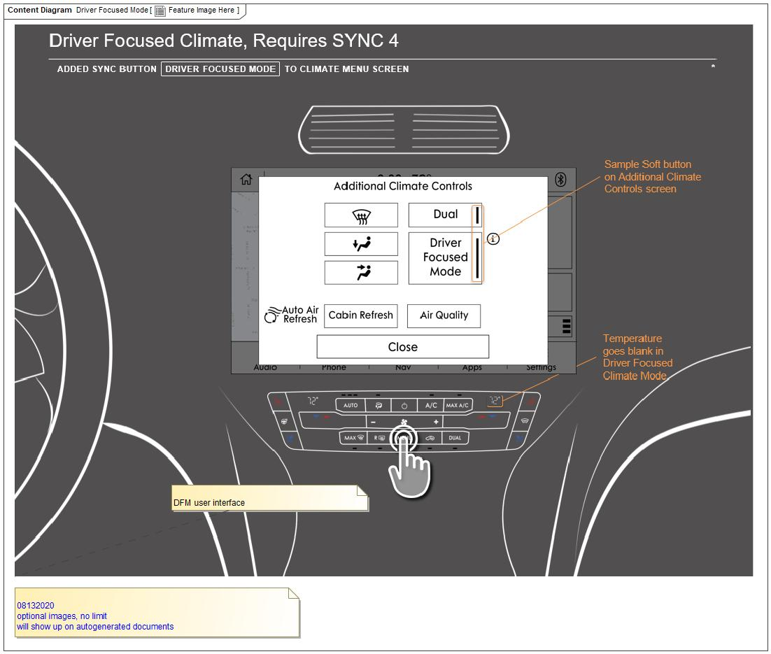

Figure 2: Feature Image Here

## Feature Variants

|  |  |  |
| --- | --- | --- |
| **Variant Name** | **Variant Description** | **Remarks** |
| **Driver Focused Mode** |  |  |
| **Driver Focused Mode Lite** | A subset of the full feature: may be just the floor plenum assembly |  |

Table 2: Feature Variants

### Regions & Markets

|  |  |  |  |  |  |  |
| --- | --- | --- | --- | --- | --- | --- |
| **Market /**  **Region**  Variant Name | **North America** | **South America** | **Europe** | **Middle East/Africa** | **Asia / Pacific** | **China** |
| **Driver Focused Mode** | No | No | Mandatory | No | No | No |
| **Driver Focused Mode Lite** | No | No | Optional | No | No | No |

Table 3: Regions & Markets

## Input Requirements

### Legal Requirements

* : Compliance with FMVSS101
  + The DFM feature shall comply with FMVSS101.

### Trustmark Requirements

* : CCM & ECP
  + The DFM feature shall comply with the Global Electrical Design Specification for Climate Control Modules and Electronic Control Panel, DSGB5T-18C612-B
* : Electronic Control Panel
  + The DFM feature shall comply with the Electronic Control Panel Functional Specification, FSFR3T-18C612-AG
* : HVAC Air Distribution
  + The DFM feature shall comply with the Climate HVAC Airflow Distribution, CC-0016

### Industry Standards

* : ISO 26262
  + The system should be developed according to Ford's implementation of Functional Safety.

### Attribute Requirements

#### : User Experience - NVH

* + Optimized cooling/heating shall maintain a comfortable noise level for 80% of the users.

#### : Energy Consumption

* + The cooling/heating functionality shall be provided only to the occupants present in the vehicle.

#### : User Experience - Cabin Comfort

* + The vehicle shall provide the occupants a consistent comfort level in cabin during a drive cycle, whether the optimized cooling/heating functionality is active or not.

## Lessons Learned

No lessons learned specified.

## Assumptions

No Assumptions specified.

# Feature Context

## Feature Context Diagram

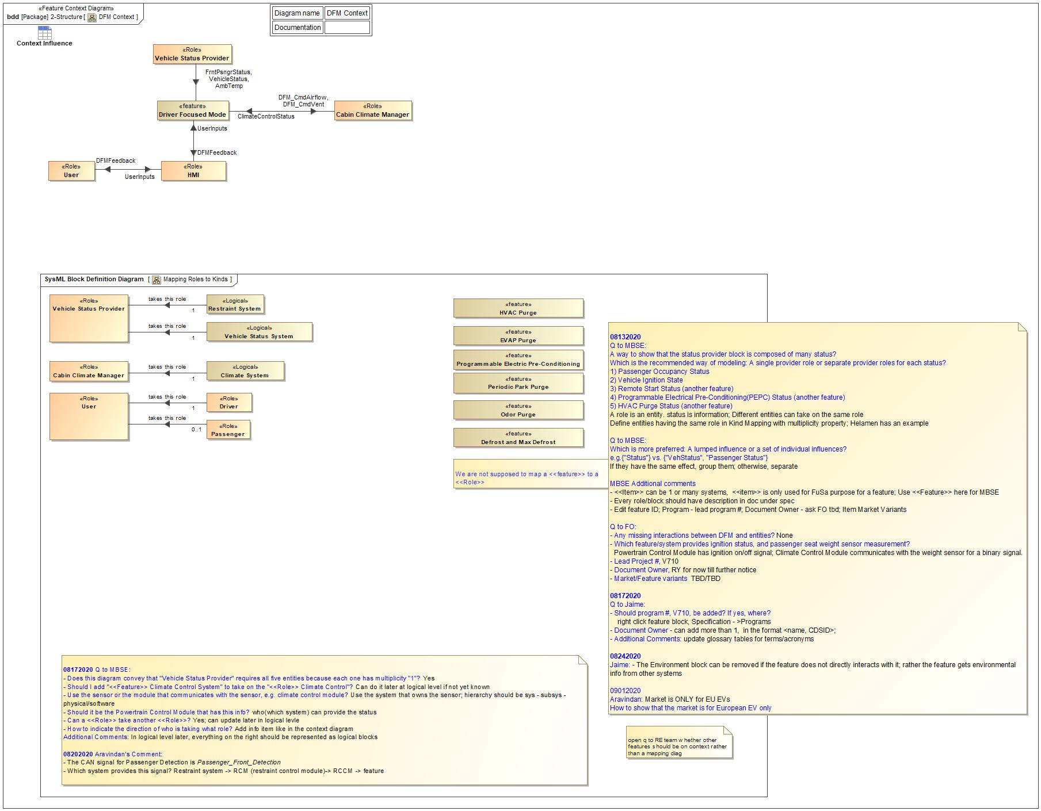

Figure 4: DFM Context

## List of Influences

|  |  |  |
| --- | --- | --- |
| **ID** | **External Entity** | **Influence Description** |
| AmbTemp | Vehicle Status Provider To Driver Focused Mode | Ambient Temperature; DFM cannot activate if AmbTemp is below 10°F |
| ClimateControlStatus | Cabin Climate Manager To Driver Focused Mode | Climate control provides climate system current state:  1) EVAP Purge Active or Inactive  2) HVAC Purge Active or Inactive  3) Programmable Electrical Pre-Conditioning(PEPC) (another feature) Active or Inactive  4) Odor Purge Active or Inactive  5) Periodic Park Purge (another feature) Active or Inactive  6) Defrost or Max Defrost Active or Inactive |
| DFMFeedback | Driver Focused Mode To HMI | DFM displays status to users, ON or OFF; If ON, FrntPsngr side temperature display will be turned off. |
| HMI To User | DFM displays status to users, ON or OFF; If ON, FrntPsngr side temperature display will be turned off. |
| DFM_CmdAirflow | Driver Focused Mode To Cabin Climate Manager | DFM sends control commands to climate control system for blower adjustment. |
| DFM_CmdVent | Driver Focused Mode To Cabin Climate Manager | DFM sends control commands to climate control system for vent door adjustment. |
| FrntPsngrStatus | Vehicle Status Provider To Driver Focused Mode | Front Passenger Seat, Vacant or Occupied |
| UserInputs | HMI To Driver Focused Mode | User inputs that may change DFM behavior:  1) Enable or disable DFM  2) Change FrntPsngr temperature setpoint  3) Enable or disable Dual Mode |
| User To HMI | User inputs that may change DFM behavior:  1) Enable or disable DFM  2) Change FrntPsngr temperature setpoint  3) Enable or disable Dual Mode |
| VehicleStatus | Vehicle Status Provider To Driver Focused Mode | A general representation of all relevant vehicle status. Currently:  1) Vehicle ignition ON or OFF |

Table 9: List of Influences

# Feature Modeling

## Operation Modes and States

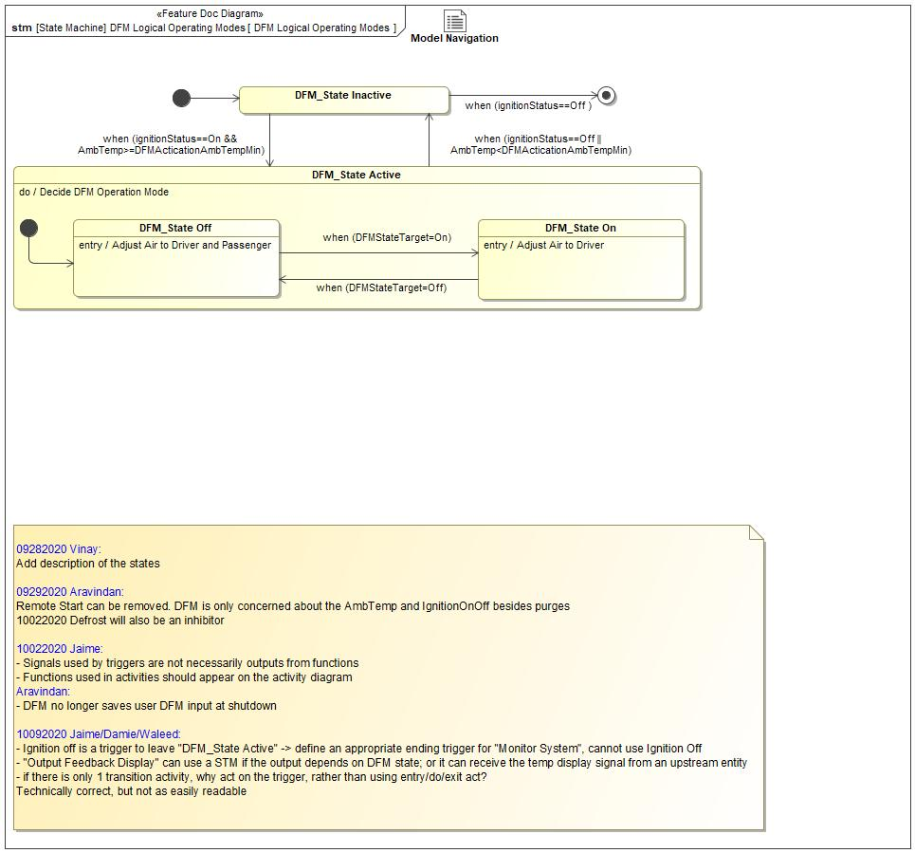

Figure 5: DFM Logical Operating Modes

|  |  |  |
| --- | --- | --- |
| **State** | **Description** | **Requirements Reference** (optional) |
| DFM_State Active | The primary state provided to allow driver and/or front passenger to control airflow towards their desired side. This includes the sub-states "DFM_State On", and "DFM_State Off".  Do behavior: Decide DFM Operation Mode |  |
| DFM_State Inactive | The state when vehicle level enabling conditions are not met for DFM to start monitor system and process requests. The enabling conditions are:  1) Ambient temperature >=10°F  2) Ignition is ON |  |
| DFM_State Off | The state provided to allow the driver to have airflow towards both the driver and the front passenger, either when a request for DFM to be Off, or when there exist an inhibitor.  Entry behavior: Adjust Air to Driver and Passenger |  |
| DFM_State On | The state provided to allow the driver have air flow towards on the driver side, when a DFM request is received and there is no inhibitors.  Entry behavior: Adjust Air to Driver |  |

Table 10: Operation Modes and States on DFM Logical Operating Modes

|  |  |  |  |  |
| --- | --- | --- | --- | --- |
| **Transition ID** | **Source** | **Destination** | **Description** | **Requirements Reference**  (optional) |
| T1 | DFM_State Off | DFM_State On | ChangeEvent when (DFMStateTarget=On) |  |
| T2 | DFM_State Active | DFM_State Inactive | ChangeEvent when (ignitionStatus==Off || AmbTemp<DFMActicationAmbTempMin) |  |
| T3 |  |  |  |  |
| T4 | DFM_State On | DFM_State Off | ChangeEvent when (DFMStateTarget=Off) |  |
| T5 | DFM_State Inactive | a | ChangeEvent when (ignitionStatus==Off ) |  |
| T6 |  |  |  |  |
| T7 | DFM_State Inactive | DFM_State Active | ChangeEvent when (ignitionStatus==On && AmbTemp>=DFMActicationAmbTempMin) |  |

Table 11: Transitions between Operation Modes and States on DFM Logical Operating Modes

## Use Cases

### Use Case Diagram

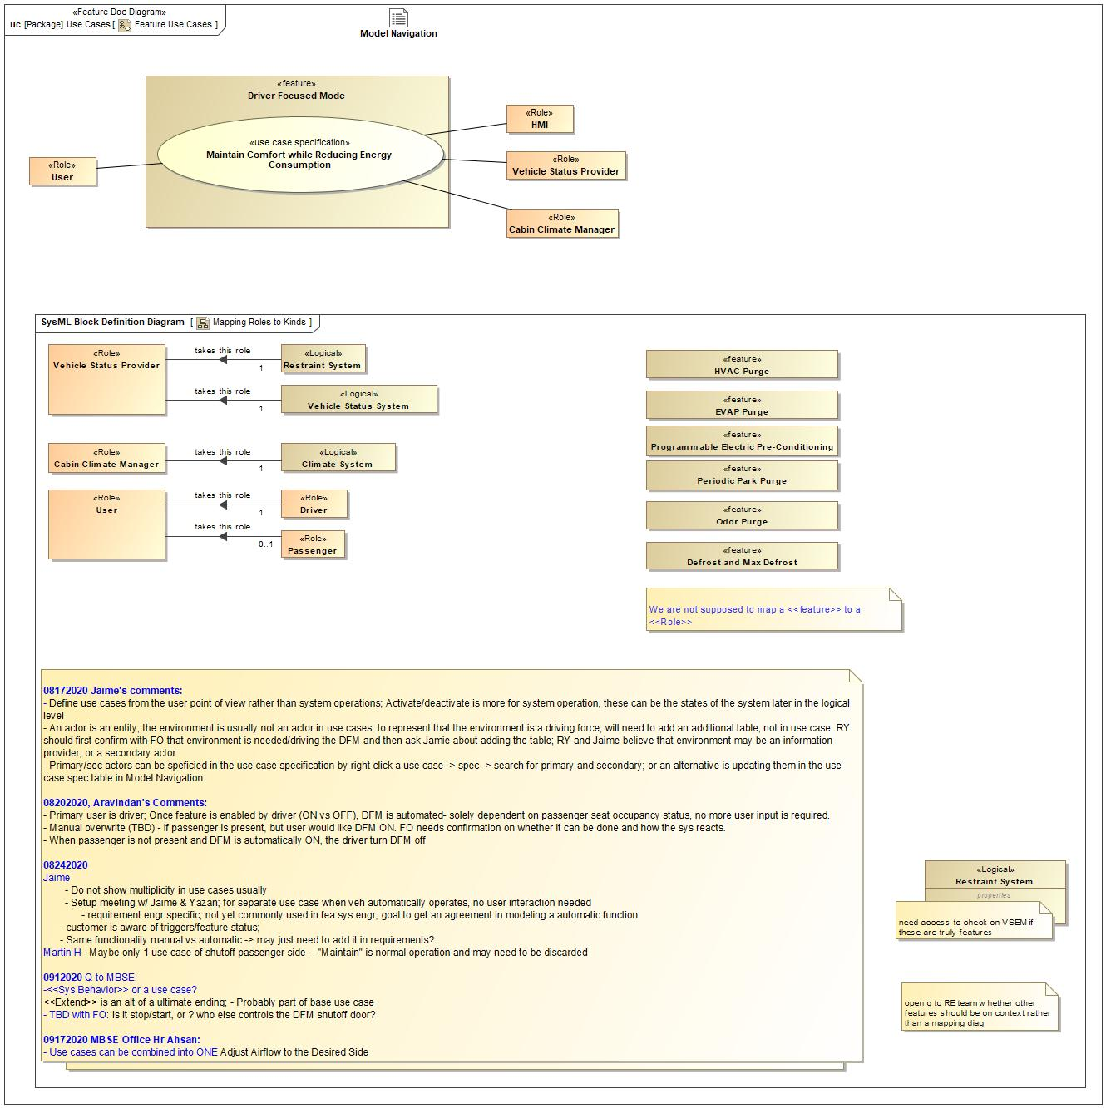

Figure 6: Feature Use Cases

### Actors

| **Actor** | **Description** |
| --- | --- |
| Cabin Climate Manager | A role to manage climate control in vehicle for the driver and the passenger sides. |
| HMI | Human-Machine Interfaces provides digital signal to DFM and visual feedback to users |
| User | Users can be the driver and/or the passenger. User behavior can change DFM state. Both driver and passenger can manually enable/disable DFM through HMI buttons. Passenger effect on the front passenger seat may affect the input to DFM automatic strategy. |
| Vehicle Status Provider | Multiple entities on the vehicle to provide required information to operate DFM. |

Table 12: List of Actors

### Use Case Descriptions

Maintain Comfort while Reducing Energy Consumption

|  |  |  |
| --- | --- | --- |
| **Actors** | Primary | User |
| Secondary | Vehicle Status Provider |
| Secondary | Cabin Climate Manager |
| Secondary | HMI |
| **Subject** |  | Driver Focused Mode |
| **Description** |  | The main use case where DFM is maintaining comfort level while reducing energy consumption regardless of trigger type. |
| **Preconditions** | PreC1 | Vehicle is Off |
| **Triggers** | T1 | Vehicle Status Provider provides that vehicle ignition status is On |
| **Main Flow Description** |  | DFM request airflow for energy consumption concerns |
| **Main Flow** | M1 | Vehicle Status Provider provides front passenger seat occupancy status, vehicle ignition status,ambient temperature |
| M2 | Climate System provides climate system status |
| M3 | DFM requests airflow to only the driver if front passenger seat occupancy sensor detects a passenger; otherwise, DFM performs no action |
| M4 | The above steps repeat until vehicle shutdown |
| M5 | Vehicle Status Provider provides vehicle ignition is Off |
| **Alternative Flow Description** |  | DFM requests airflow based on user comfort concerns |
| **Alternative Flow Steps** | A1 | HMI Provides User Input |
| A2 | Vehicle Status Provider provides front passenger seat occupancy status, vehicle ignition status,ambient temperature |
| A3 | Climate System provides climate system status |
| A4 | If user requests DFM to be On, DFM requests airflow to only the driver; otherwise, DFM performs no action |
| A5 | The above steps repeat until vehicle shutdown |
| A6 | Vehicle Status Provider provides vehicle ignition is Off |
| **Postconditions** | PostC1 | Vehicle is Off and DFM is inactive |

## Driving and Operation Scenarios

Main Scenario: Energy Conservation

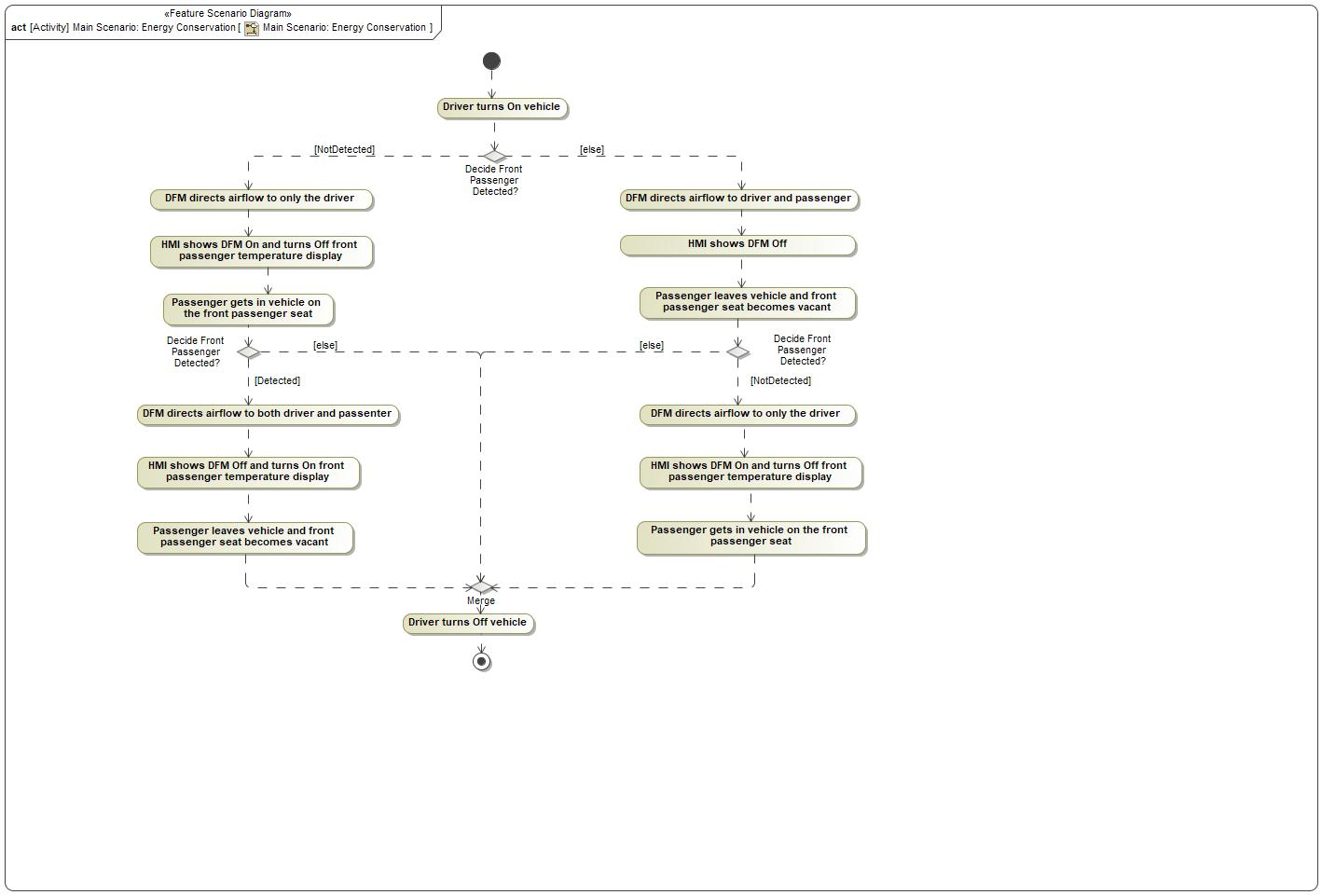

|  |  |
| --- | --- |
| **Flow of Actions** | |
| 1 | Driver turns On vehicle |

Old Scenario: Direct Air to Desired Side

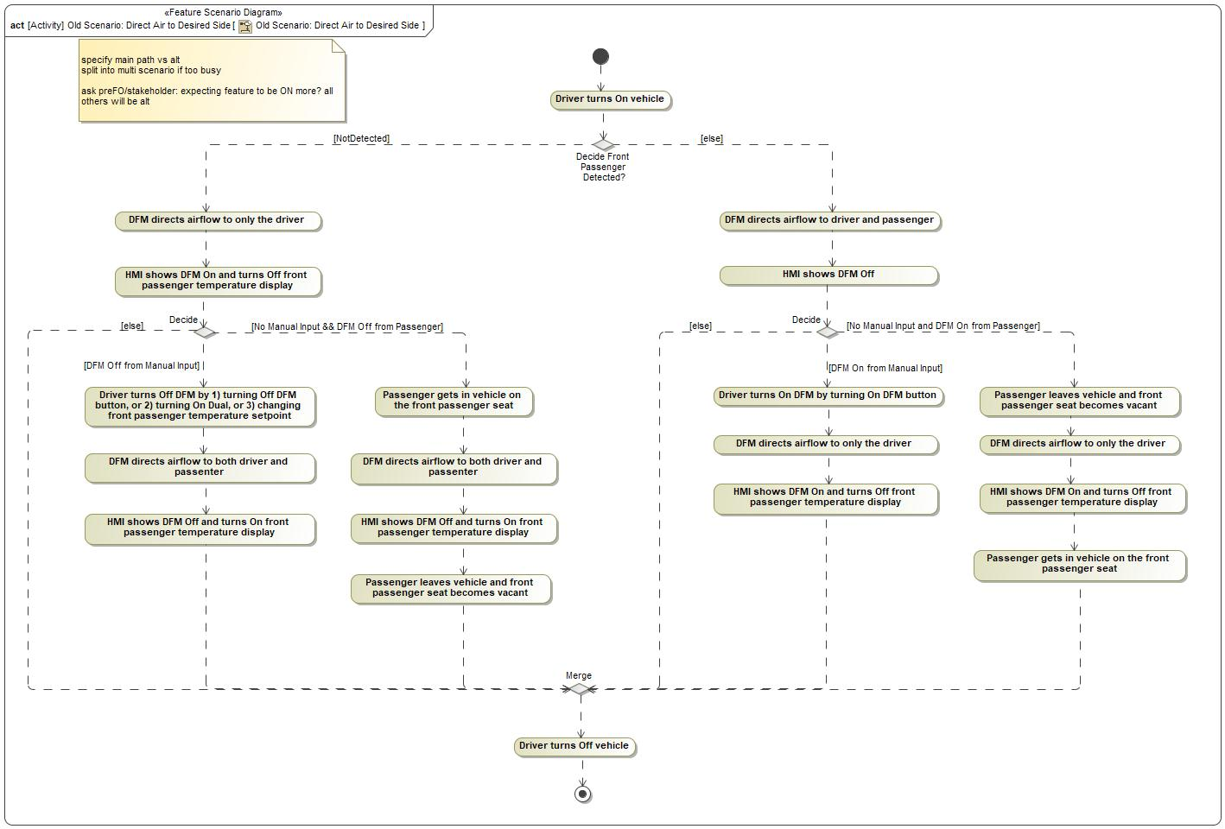

|  |  |
| --- | --- |
| **Flow of Actions** | |
| 1 | Driver turns On vehicle |

Secondary Scenario: User Comfort

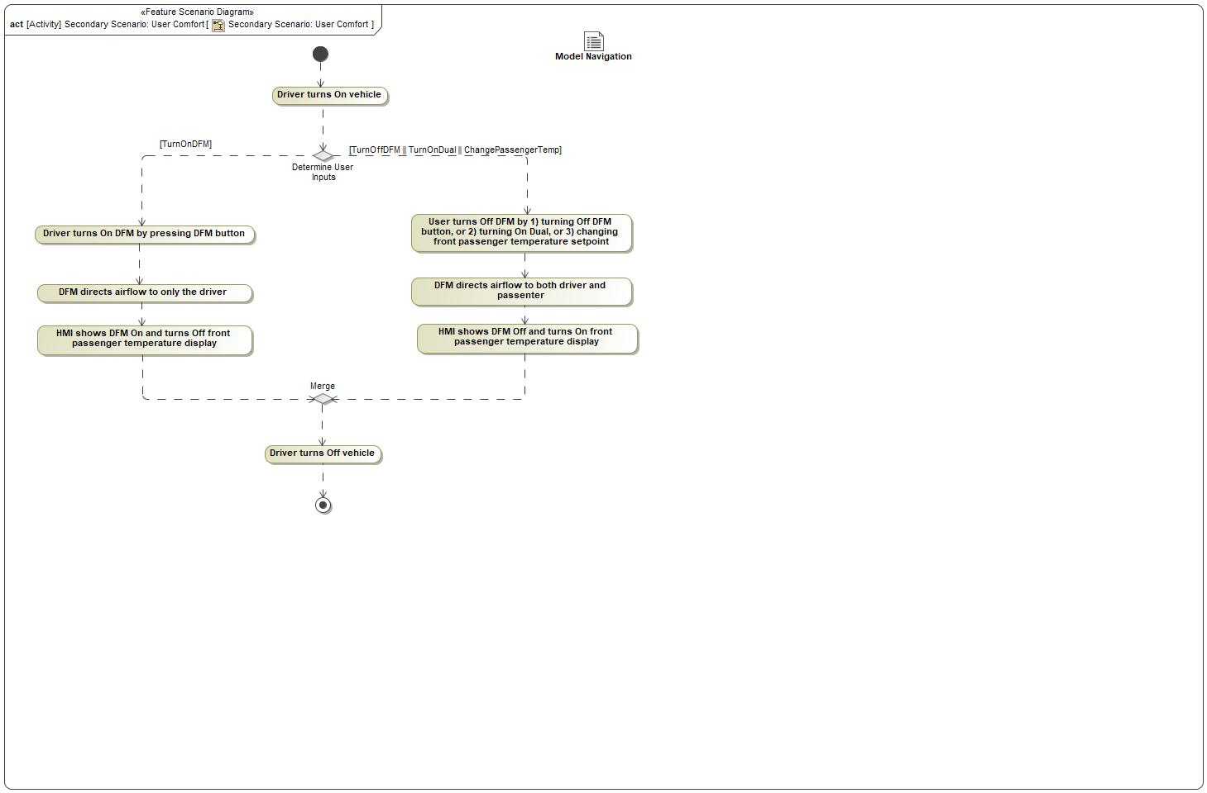

|  |  |
| --- | --- |
| **Flow of Actions** | |
| 1 | Driver turns On vehicle |

## Decision Tables

*Not supported by MagicDraw report generation.*

# Feature Requirements

## Functional Requirements

DFM Transition Time

When the DFM feature changes state, the blower speed shall transition over the period of time less than MaxTransitionTime.

|  |  |  |  |  |  |  |  |
| --- | --- | --- | --- | --- | --- | --- | --- |
| Requirement ID: | | | | | | | |
| **Rationale** | Limit transition time for enjoyable user experience | | | | | | |
| **Acceptance Criteria** | Observe that blower speed ajustment and vent open/closure is completed within MaxTransitionTime when DFM changes state | | | | | | |
| **Notes** |  | | | | | | |
| **Source** |  | | | | | **Owner** |  |
| **Source Req.** | * -759723189.jpg User Experience - Cabin Comfort | | | | | **V&V Method** |  |
| **Type** |  | | | **Priority** |  | **Status** | In-Progress |
| [Req. Template](http://wiki.ford.com/display/RequirementsEngineering/Requirements+Attributes) Version | | 6.0 | End of Requirement | | | | |

Inhibitors

When active, the following features shall inhibit the DFM feature :

1) Pre-conditioning EV(PEPC)

2) HVAC Purge

3) EVAP Purge

4) Odor Purge

5) Periodic Park Purge

6) Defrost/Max. Defrost

|  |  |  |  |  |  |  |  |
| --- | --- | --- | --- | --- | --- | --- | --- |
| Requirement ID: | | | | | | | |
| **Rationale** | Allow features with higher priority to complete first | | | | | | |
| **Acceptance Criteria** | Observe that climate system purge activities are not affected by DFM behavior | | | | | | |
| **Notes** |  | | | | | | |
| **Source** |  | | | | | **Owner** |  |
| **Source Req.** | * -759723189.jpg Energy Consumption | | | | | **V&V Method** |  |
| **Type** |  | | | **Priority** |  | **Status** | In-Progress |
| [Req. Template](http://wiki.ford.com/display/RequirementsEngineering/Requirements+Attributes) Version | | 6.0 | End of Requirement | | | | |

Passenger NOT Detected

While the DFM feature is active, it shall request HVAC airflow to front passenger side, if it detects no front passenger presence.

|  |  |  |  |  |  |  |  |
| --- | --- | --- | --- | --- | --- | --- | --- |
| Requirement ID: | | | | | | | |
| **Rationale** | Reduce energy consumption when psngr side heating/cooling is not necessary | | | | | | |
| **Acceptance Criteria** | Energy consumption is reduced when DFM is On compared to that when DFN is Off | | | | | | |
| **Notes** |  | | | | | | |
| **Source** |  | | | | | **Owner** |  |
| **Source Req.** | * -759723189.jpg User Experience - NVH * -759723189.jpg Energy Consumption * -759723189.jpg User Experience - Cabin Comfort | | | | | **V&V Method** |  |
| **Type** |  | | | **Priority** |  | **Status** | In-Progress |
| [Req. Template](http://wiki.ford.com/display/RequirementsEngineering/Requirements+Attributes) Version | | 6.0 | End of Requirement | | | | |

Vehicle Enabling Conditions

The DFM feature shall become active only when ignition is On and ambient temperature is greater or equal to DFMActicationAmbTempMin.

|  |  |  |  |  |  |  |  |
| --- | --- | --- | --- | --- | --- | --- | --- |
| Requirement ID: | | | | | | | |
| **Rationale** | Disable the feature when vehicle level conditions cannot be met | | | | | | |
| **Acceptance Criteria** | Observe that DFM cannot be turned on when ignition is off or ambient temperature is below DFMActicationAmbTempMin | | | | | | |
| **Notes** |  | | | | | | |
| **Source** |  | | | | | **Owner** |  |
| **Source Req.** | * -759723189.jpg Energy Consumption | | | | | **V&V Method** |  |
| **Type** |  | | | **Priority** |  | **Status** | In-Progress |
| [Req. Template](http://wiki.ford.com/display/RequirementsEngineering/Requirements+Attributes) Version | | 6.0 | End of Requirement | | | | |

User Input Received

If a user input changes the state of the DFM feature, the DFM feature shall follow the user request for the rest of the drive cycle.

|  |  |  |  |  |  |  |  |
| --- | --- | --- | --- | --- | --- | --- | --- |
| Requirement ID: | | | | | | | |
| **Rationale** | Follow user request not passenger detection when user intent is received | | | | | | |
| **Acceptance Criteria** | Observe that DFM is Off when user requests so even if a front passenger is present | | | | | | |
| **Notes** |  | | | | | | |
| **Source** |  | | | | | **Owner** |  |
| **Source Req.** | * -759723189.jpg User Experience - Cabin Comfort | | | | | **V&V Method** |  |
| **Type** |  | | | **Priority** |  | **Status** | In-Progress |
| [Req. Template](http://wiki.ford.com/display/RequirementsEngineering/Requirements+Attributes) Version | | 6.0 | End of Requirement | | | | |

Test Functional Requirement

|  |  |  |  |  |  |  |  |
| --- | --- | --- | --- | --- | --- | --- | --- |
| Requirement ID: | | | | | | | |
| **Rationale** |  | | | | | | |
| **Acceptance Criteria** |  | | | | | | |
| **Notes** |  | | | | | | |
| **Source** |  | | | | | **Owner** |  |
| **Source Req.** |  | | | | | **V&V Method** |  |
| **Type** |  | | | **Priority** |  | **Status** |  |
| [Req. Template](http://wiki.ford.com/display/RequirementsEngineering/Requirements+Attributes) Version | | 6.0 | End of Requirement | | | | |

### Error Handling

Error Handling

When the passenger occupancy status cannot be determined, the DFM feature shall assume a passenger is present.

|  |  |  |  |  |  |  |  |
| --- | --- | --- | --- | --- | --- | --- | --- |
| Requirement ID: | | | | | | | |
| **Rationale** | Ensure the comfort level of occupants not jeopadized | | | | | | |
| **Acceptance Criteria** | Observe that feature assumes passenger present when passenger occupancy status cannot be determined | | | | | | |
| **Notes** |  | | | | | | |
| **Source** |  | | | | | **Owner** |  |
| **Source Req.** | * -759723189.jpg User Experience - Cabin Comfort | | | | | **V&V Method** |  |
| **Type** |  | | | **Priority** |  | **Status** | In-Progress |
| [Req. Template](http://wiki.ford.com/display/RequirementsEngineering/Requirements+Attributes) Version | | 6.0 | End of Requirement | | | | |

## Non-Functional Requirements

### Safety

*Not supported by MagicDraw report generation.*

### Security

No Security Requirements specified.

### Reliability

No Reliability Requirements specified.

## HMI Requirements

HMI Display of DFM State

The DFM feature shall inform users of its current state through HMI.

|  |  |  |  |  |  |  |  |
| --- | --- | --- | --- | --- | --- | --- | --- |
| Requirement ID: | | | | | | | |
| **Rationale** | Provide user visual feedback of DFM State | | | | | | |
| **Acceptance Criteria** | Observe that DFM state is displayed ON or OFF on HMI | | | | | | |
| **Notes** |  | | | | | | |
| **Source** |  | | | | | **Owner** |  |
| **Source Req.** | * -759723189.jpg User Experience - Cabin Comfort | | | | | **V&V Method** |  |
| **Type** |  | | | **Priority** |  | **Status** | In-Progress |
| [Req. Template](http://wiki.ford.com/display/RequirementsEngineering/Requirements+Attributes) Version | | 6.0 | End of Requirement | | | | |

HMI DFM Switch

The DFM feature shall provide users with means through HMI to activate and deactivate the DFM functionality.

|  |  |  |  |  |  |  |  |
| --- | --- | --- | --- | --- | --- | --- | --- |
| Requirement ID: | | | | | | | |
| **Rationale** | Provide user the ability to manually activate/deactivate DFM | | | | | | |
| **Acceptance Criteria** | Observe that a user input exists for DFM on HMI | | | | | | |
| **Notes** |  | | | | | | |
| **Source** |  | | | | | **Owner** |  |
| **Source Req.** | * -759723189.jpg User Experience - Cabin Comfort | | | | | **V&V Method** |  |
| **Type** |  | | | **Priority** |  | **Status** | In-Progress |
| [Req. Template](http://wiki.ford.com/display/RequirementsEngineering/Requirements+Attributes) Version | | 6.0 | End of Requirement | | | | |

## Other Requirements

### Design Requirements

*Not supported by MagicDraw report generation.*

### Manufacturing Requirements

No Manufacturing Requirements specified.

### Service Requirements

No Service Requirements specified.

#### **Cloud Connectivity Data Analytics Requirements**

### After Sales Requirements

Owner's Manual Updates

Owner’s manual shall include description of the DFM feature .

|  |  |  |  |  |  |  |  |
| --- | --- | --- | --- | --- | --- | --- | --- |
| Requirement ID: | | | | | | | |
| **Rationale** |  | | | | | | |
| **Acceptance Criteria** |  | | | | | | |
| **Notes** |  | | | | | | |
| **Source** |  | | | | | **Owner** |  |
| **Source Req.** |  | | | | | **V&V Method** |  |
| **Type** |  | | | **Priority** |  | **Status** | In-Progress |
| [Req. Template](http://wiki.ford.com/display/RequirementsEngineering/Requirements+Attributes) Version | | 6.0 | End of Requirement | | | | |

### Process Requirements

No Process Requirements specified.

# Functional Safety

## System Behaviors for HARA

No System Behaviors specified.

## Safety Assumptions

No Safety Assumptions specified

## Safety Goals

|  |  |  |  |  |
| --- | --- | --- | --- | --- |
| ID | Goal | | | |
|  | **Goal Name** | Prevent Hazard (Example) | | |
| **Description** |  | | |
| **Safety Goal Concept** | Safety Goal Concept:  Warning & Recovery Concept: | | |
| **ASIL** |  | **FTTI** |  |
| **Related FSR IDs** |  | | |

Table 15: Functional Safety Goals

## Functional Safety Requirements

### Safety Goal: Prevent Hazard (Example)

**Name:** Prevent Hazard (Example)

**Purpose:**

**Text:**

**ASIL:**

#### Safety Goal Concept

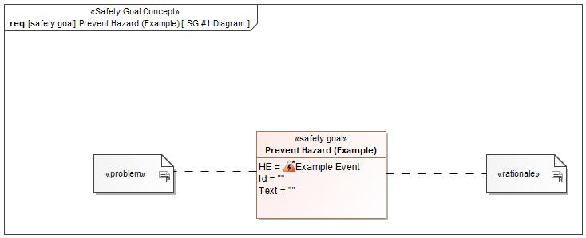

Figure 1: SG #1 Diagram – Prevent Hazard (Example)

*Note: The authoritative source for the Safety Goals is document “FFSD 02 Hazard Analysis* *and Risk Assessment”. The documentation of Safety Goals in this chapter (In the Argumentation for Safety Goal achievement) is for information purposes only.*

*The authoritative source for the Functional Safety Requirements is section 2.1.x.3: of this document. The documentation of Functional Safety Requirements in the following chapter (complete or summarised) is for information purposes only.*

#### Warning and Recovery Concept

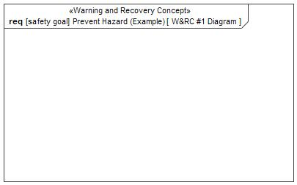

Figure 7: W&RC #1 Diagram – Prevent Hazard (Example)

#### FSRs for - Prevent Hazard (Example)

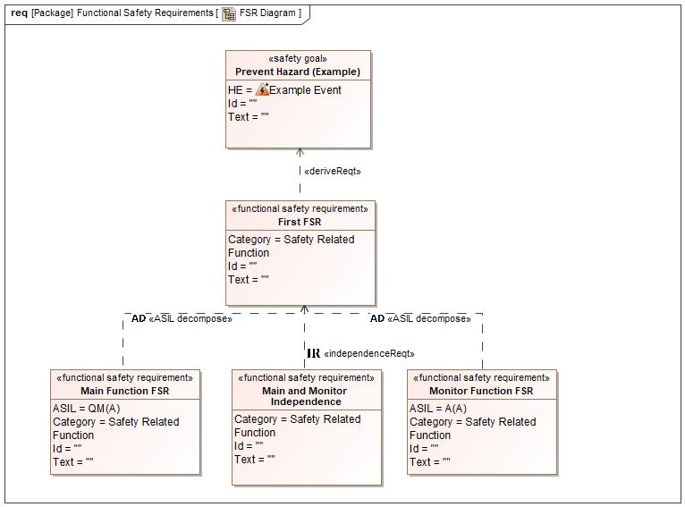

Figure 1. Prevent Hazard (Example)

Monitor Function FSR

Satisfied by:

* Logicals:
  + Climate System

Related to:

* Safe States:
  + Safe State #1
* Operating Modes:
  + DFM_State On

|  |  |  |  |  |  |  |  |
| --- | --- | --- | --- | --- | --- | --- | --- |
| Requirement ID: | | | | | | | |
| **Purpose** |  | | | | | | |
| **V&V Acceptance Criteria** |  | | | | | | |
| **Notes** |  | | | | | | |
| **Source** |  | | | | | **Owner** |  |
| **Source Req.** | * 597771748.jpg Prevent Hazard (Example) | | | | | **V&V Method** |  |
| **Type** | N/A | | **Priority** | | N/A | **Status** |  |
| **ASIL** | A(A) | | **Category** | | Safety Related Function | **Fault Handling Time** | N/A |
| [Req. Template](http://wiki.ford.com/display/RequirementsEngineering/Requirements+Attributes) Version | | 6.0 | | End of Requirement | | | |

First FSR

Satisfied by:

* Logicals:
  + Psngr Outboard Floor Vent

Related to:

* Safe States:
  + Safe State #1
* Operating Modes:
  + DFM_State On

|  |  |  |  |  |  |  |  |
| --- | --- | --- | --- | --- | --- | --- | --- |
| Requirement ID: | | | | | | | |
| **Purpose** |  | | | | | | |
| **V&V Acceptance Criteria** |  | | | | | | |
| **Notes** |  | | | | | | |
| **Source** |  | | | | | **Owner** |  |
| **Source Req.** | * 597771748.jpg Prevent Hazard (Example) | | | | | **V&V Method** |  |
| **Type** | N/A | | **Priority** | | N/A | **Status** |  |
| **ASIL** |  | | **Category** | | Safety Related Function | **Fault Handling Time** | N/A |
| [Req. Template](http://wiki.ford.com/display/RequirementsEngineering/Requirements+Attributes) Version | | 6.0 | | End of Requirement | | | |

Main and Monitor Independence

Satisfied by:

* Logicals:
  + Climate System

Related to:

* Safe States:
  + Safe State #1
* Operating Modes:
  + DFM_State On

|  |  |  |  |  |  |  |  |
| --- | --- | --- | --- | --- | --- | --- | --- |
| Requirement ID: | | | | | | | |
| **Purpose** |  | | | | | | |
| **V&V Acceptance Criteria** |  | | | | | | |
| **Notes** |  | | | | | | |
| **Source** |  | | | | | **Owner** |  |
| **Source Req.** | * 597771748.jpg Prevent Hazard (Example) | | | | | **V&V Method** |  |
| **Type** | N/A | | **Priority** | | N/A | **Status** |  |
| **ASIL** |  | | **Category** | | Safety Related Function | **Fault Handling Time** | N/A |
| [Req. Template](http://wiki.ford.com/display/RequirementsEngineering/Requirements+Attributes) Version | | 6.0 | | End of Requirement | | | |

Main Function FSR

Satisfied by:

* Logicals:
  + Climate System

Related to:

* Safe States:
  + Safe State #1
* Operating Modes:
  + DFM_State On

|  |  |  |  |  |  |  |  |
| --- | --- | --- | --- | --- | --- | --- | --- |
| Requirement ID: | | | | | | | |
| **Purpose** |  | | | | | | |
| **V&V Acceptance Criteria** |  | | | | | | |
| **Notes** |  | | | | | | |
| **Source** |  | | | | | **Owner** |  |
| **Source Req.** | * 597771748.jpg Prevent Hazard (Example) | | | | | **V&V Method** |  |
| **Type** | N/A | | **Priority** | | N/A | **Status** |  |
| **ASIL** | QM(A) | | **Category** | | Safety Related Function | **Fault Handling Time** | N/A |
| [Req. Template](http://wiki.ford.com/display/RequirementsEngineering/Requirements+Attributes) Version | | 6.0 | | End of Requirement | | | |

### Derivation of Functional Safety Requirements on Assumptions

No Functional Safety Requirements tracing to Assumptions specified.

## ASIL Decomposition of Functional Safety Requirements

### Decomposition of Functional Safety Requirement

| Initial Safety Requirement | First FSR | |
| --- | --- | --- |
| Decomposition Rationale |  | |
| Method for Decomposition | A -> A(A) + QM(A) | |
| Functional Safety Requirement 1 after Decomposition | F-S-Req-ID |  |
| F-S-Req. Title | Monitor Function FSR |
| ASIL | A(A) |
| Rationale |  |
| Satisfied by | * Climate System |
| Functional Safety Requirement 2 after Decomposition | F-S-Req-ID |  |
| F-S-Req. Title | QM(A) |
| ASIL | Main Function FSR |
| Rationale |  |
| Satisfied by | * Climate System |
| Functional Safety Requirement for Independence | F-S-Req.-ID |  |
| F-S-Req. Title | Main and Monitor Independence |
| ASIL |  |
| Rationale |  |

# CyberSecurity

## Security Goals

|  |  |  |
| --- | --- | --- |
| ID | Goal | |
|  | **Goal Name** |  |
| **Description** |  |
| **CAL** |  |
| **Related CSR IDs** |  |
|  | **Goal Name** |  |
| **Description** |  |
| **CAL** |  |
| **Related CSR IDs** |  |
|  | **Goal Name** |  |
| **Description** |  |
| **CAL** |  |
| **Related CSR IDs** |  |

Table 18: Cybersecurity Goals

## Cybersecurity Requirements

# Architecture

## Functional Architecture

### List of Functions

## Logical Architecture

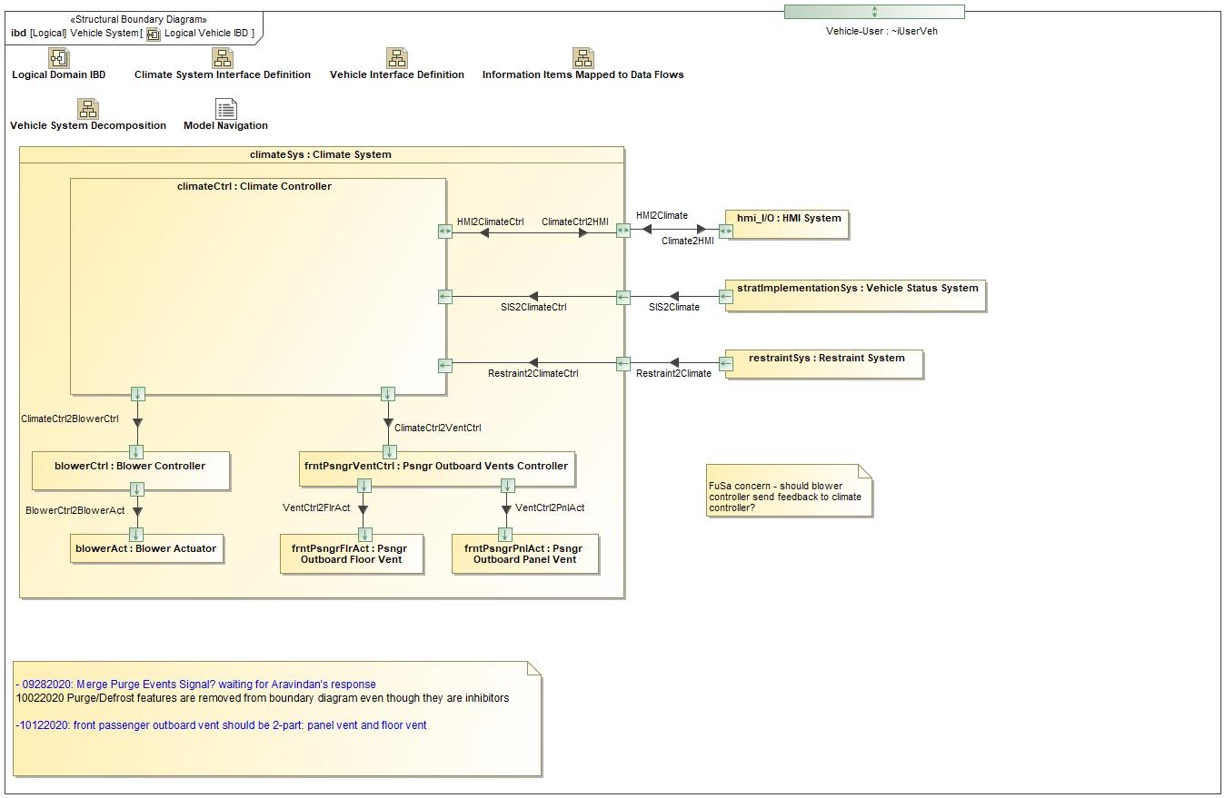

Figure 9: Logical Vehicle IBD

### Logical Elements

|  |  |  |  |
| --- | --- | --- | --- |
| **Element Name** | **Description** | **Allocated Functions** | **Comments** |
| Blower Actuator | Blower motor in the climate system. It receives blower speed command and adjusts air flow rate. |  |  |
| Blower Controller | Controller of the blower motor |  |  |
| Climate Controller | Controller for the entire climate system |  |  |
| Climate System | Climate system |  |  |
| HMI System | Human Machine Interface for receive user inputs and display DFM related notifications |  |  |
| Psngr Outboard Floor Vent | The vent door in the HVAC air duct towards the passenger side near the floor to adjust flow |  |  |
| Psngr Outboard Panel Vent | The vent door in the HVAC air duct towards the passenger side on the instrument panel to adjust flow |  |  |
| Psngr Outboard Vents Controller | Controller for vents on the front passenger side |  |  |
| Restraint System | Restraint System |  |  |
| Vehicle Status System | Vehicle status system providing ignition status and ambient temperature |  |  |

Table 19: Logical Elements

### Logical Interfaces

|  |  |  |  |
| --- | --- | --- | --- |
| **Interface** | **Direction** | **Description** | **Value Range** |
| BlowerCtrl2BlowerAct | (Blower Controller) To (Blower Actuator) |  | as BlowerCmd:   * voltage |
| Climate2HMI | (Climate System) To (HMI System) |  | as DFMFeedback:   * dfmStateDisplay * frntPsngrTempDisplay |
| ClimateCtrl2BlowerCtrl | (Climate Controller) To (Blower Controller) |  | blowerCmd  as BlowerCmd:   * voltage |
| ClimateCtrl2HMI | (Climate Controller) To (Climate System) |  | as DFMFeedback:   * dfmStateDisplay * frntPsngrTempDisplay |
| ClimateCtrl2VentCtrl | (Climate Controller) To (Psngr Outboard Floor Vent) |  | frntPsngrOutPnlCmd  as VentCmd:   * FullyOpen * FullyClosed   frntPsngrOutFlrCmd  as VentCmd:   * FullyOpen * FullyClosed |
| (Climate Controller) To (Psngr Outboard Vents Controller) |  | frntPsngrOutPnlCmd  as VentCmd:   * FullyOpen * FullyClosed   frntPsngrOutFlrCmd  as VentCmd:   * FullyOpen * FullyClosed |
| HMI2Climate | (HMI System) To (Climate System) |  | as UserInputs:   * userInDFM * userInDual * userInTempChange |
| HMI2ClimateCtrl | (Climate System) To (Climate Controller) |  | as UserInputs:   * userInDFM * userInDual * userInTempChange |
| Restraint2Climate | (Restraint System) To (Climate System) |  | as FrntPsngrOccupancyStatus:   * frntPsngrStatus |
| Restraint2ClimateCtrl | (Climate System) To (Climate Controller) |  | as FrntPsngrOccupancyStatus:   * frntPsngrStatus |
| SIS2Climate | (Vehicle Status System) To (Climate System) |  | as AmbTemp:  as VehStatus:   * ignitionStatus |
| SIS2ClimateCtrl | (Climate System) To (Climate Controller) |  | as AmbTemp:  as VehStatus:   * ignitionStatus |
| VentCtrl2FlrAct | (Psngr Outboard Vents Controller) To (Psngr Outboard Floor Vent) |  | as VentCmd:   * FullyOpen * FullyClosed |
| VentCtrl2PnlAct | (Psngr Outboard Vents Controller) To (Psngr Outboard Panel Vent) |  | as VentCmd:   * FullyOpen * FullyClosed |

Table 18: Feature Interactions

# Open Concerns

| ID | Concern Description | e-Tracker / Reference | Responsible | Status | Solution |
| --- | --- | --- | --- | --- | --- |
| 1 |  |  |  |  |  |

Table 20: Open Concerns *(Not supported by MagicDraw report generation)*

# Revision History

No Revision History found.

## Template Revisions

|  |  |  |  |  |
| --- | --- | --- | --- | --- |
| Version | Rev. | Date | Description | Responsible |
| *0* | *6* | *2015-05-26* | * *Chapter “Feature Overview” and made a 2nd level heading.* * *Chapter “Feature Modeling” divided into 3 subchapter (“Scenarios”, “Use Cases”, “State Machines”) for different modeling methods* | *Jbaden1* |
| *0* | *7* | *2015-05-27* | * *Table of Content updated* * *Template Revision History chapter added* | *Jbaden1* |
| *0* | *8* | *2015-07-02* | * *Section “Unsettled Issues” added* | *Alevin7* |
| *0* | *9* | *2015-08-04* | * *Section “Feature Variants” added* * *Section “Feature Boundary Diagram” renamed to “Feature Context Diagram”* * *Document Properties adapted to match needs of VBA macros* | *Jbaden1, Awegman1* |
| *1* | *0* | *2015-09-11* | * *Section “Feature Variants” reworked* * *Feature Goals removed. Only “Safety Goals“ chapter remains.* * *Heading 2 formatting issues corrected.* * *Requirements / Use Cases Listing removed from traceability chapter.* * *Formatting of attribute table in Notation chapter corrected* * *Open Topics / Known Issues chapter moved to the end* | *Jbaden1* |
| *1* | *1* | *2015-11-16* | * *Table-Styles removed (for smooth VSEM import)* * *Some clean-up of sections “Purpose” and “Audience”* | *Awegman1, jbaden1* |
| *1* | *2* | *2016-02-26* | * *Minor corrections based on lessons learned from CC and PCL pilot (e.g. section market/regions) and discussion with Functional Safety Team (purpose of feature)* * *Footer corrected* * *Boundary diagram interface chapter renamed to influences.* | *Jbaden1* |
| *1* | *3* | *2016-02-26* | * *Minor corrections after review with Whitney Keith from Functional Safety team* | *Jbaden1* |
| *1* | *4* | *2016-03-10* | * *Some cleanup of meta-data in Word Properties* | *Jbaden1* |
| *1* | *5* | *2016-03-10* | * *Footer formatting corrected (Issue 19)* * *Results from review with Functional Safety Team incorporated (Issue 20).* | *jbaden1* |
| *1* | *6* | *2016-04-18* | * *Scenario Template added* | *Jbaden1* |
| *1* | *7* | *2016-04-18* | * *Chapter “Operation Modes and States” moved before “Use Case” section.* | *Jbaden1* |
| *1* | *8* | *2016-04-18* | * *Broken Wiki links repaired.* | *Jbaden1* |
| *2* | *0* | *2016-05-19* | * *Adapted to Specification_Macros.dotm V2.0* * *Requirements Templates chapter (ch. 1.7.1) no longer has an attribute table, but refers directly to the Wiki..* | *Jbaden1* |
| *2* | *1* | *2016-06-10* | * *Table for Context Diagram modified (lists external entities and Influence Description only)* | *Jbaden1* |
| *2* | *2* | *2016-07-08* | * *Template version added to footer* * *Several hints added to the various sections* * *Findings from Functional Safety Team incorporated.* * *RE_SafetyRequirement style added* | *Jbaden1* |
| *2* | *3* | *2016-09-21* | * *Update from Functional Safety Team incorporated (“Lessons Learned”, “System Behaviors for HARA”)* | *Jbaden1* |
| *2* | *4* | *2016-11-15* | * *Update from Functional Safety Team incorporated (“Lessons Learned”, “System Behaviors for HARA”)* * *Explanatory notes made more formal* | *Jbaden1* |
| *3* |  |  | *Skipped to synchronize with Specification_Macros.dotm* |  |
| *4* |  |
| *5* | *0* | *2017-01-13* | * *Meta data updated for specification macros, version 3.1* * *SW Unit chapter removed for the time being* * *Green boxes added for user hints* | *Jbaden1* |
| *5* | *1* | *2017-01-18* | * *Minor editorial changes* | *Jbaden1* |
| *6* | *0* | *2017-02-03* | * *CR48: Chapter 6 renamed from “Safety” to “Functional Safety”. New sub-chapter “Safety” introduced in Non-Functional Requirements section* | *Jbaden1* |
| *6* | *0* | *2017-04-28* | * *CR7: “RequirementsTraceability” chapter removed* | *Jbaden1* |
| *6* | *0* | *2017-11-15* | * *CR32/53: New Cover Sheet + Disclaimer replaces FAP-150 like ones.* * *CR75: Some rewording -> Terminology to Glossary, Notation -> Document Conventions* * *CR49: Rename “Assumptions & Constraints” to “Assumptions”* * *CR74: Safety Assumptions added to chapter 6.* * *CR58: Add function allocation column to Logical Architecture chapter* | *Jbaden1* |
| *6* | *0* | *2018-01-31* | * *CR63: Updated links to Functional Safety Sharepoint* | *Jbaden1* |
| *6* | *0* | *2018-07-24* | * *CR69: Add FSR to FeatureDoc* * *CR64: Add new section "Design Requirements" to Function Spec and Feature Spec* | *Jbaden1* |
| *6* | *0* | *2018-08-06* | * *CR53: some corrections for metada and formatting* | *Jbaden1* |
| *6* | *0* | *2018-09-28* | * *Broken links to RE Wiki repaired* | *Jbaden1* |
| *6* | *0* | *2018-10-31* | * *Cover sheet and footer more GIS like. Functional Safety team feedback incorporated:*   + *New subsections “Functional Safety Requirements, (Decomposed) FSRs and Parameters / Values*   + *Removal of “Logical Architecture”* | *Jbaden1* |
| *6* | *0* | *2018-12-12* | * *FSR template removed, now as a macro in the Specification_Macros.dotm* | *Jbaden1* |
| *N* |  | *2019-04-03* | * *Updated code for context diagrams, actors and use cases.* * *Updated code structure with all macros at the beginning.* * *Updated code to populate assumptions using element-assumption relationship or hazardous event.* | *snuesch* |
| *N* |  | *2019-04-18* | * *Added structural boundary diagram for FuSa based on TGB discussion.* * *Added operating modes to functional safety requirements.* | *snuesch* |
| *N* |  | *2019-04-25* | * *Improved export of actions and activities on functional boundary diagram.* | *snuesch* |
| *6* | *0b* | *2019-05-23* | * *Re-introduce “Logical Architecture” (for Functional Safety)* | *Jbaden1* |
| *N* |  | *2019-06-17* | * *Aligned “Architecture” section with RE template.* * *Made “Ford Documents” table more flexible.* * *Added template terms to glossary* | *snuesch* |
| *N* |  | *2019-06-25* | * *Improved use cases to handle Primary and Secondary actors.* * *Added Performance Requirements to Uncategorized.* | *snuesch* |
| *6* | *0b* | *2019-06-26* | * *Chapter “Logical Elements” in “Logical Architecture” section added (FuSa CR 15136240)* * *“References” and “Glossary” chapter moved from section “Feature Overview” to “Introduction”. References and Glossary should be available in the document as early as possible* | *Jbaden1* |
| *N* |  | *2019-07-25* | * *Added populated “Logical Elements” table and allocated functions.* * *Export documentation field of context diagram.* | *snuesch* |
| *N* |  | *2019-08-09* | * *Export documentation field of use case diagram.* * *Fixed bug in Feature Requirement Verification Method.* * *Simplified export of References without publisher.* | *snuesch* |
| *N* |  | *2019-08-21* | * *Improved glossary and acronym tables* | *snuesch* |
| *N* |  | *2019-08-28* | * *Fixed bug in populating title in header* | *snuesch* |
| *N* |  | *2019-09-16* | * *Updated bibliography export* | *snuesch* |
| *N* |  | *2019-09-27* | * *Updated export of Verification Method and Requirement Status for Feature Requirements and V&V Method for Functional Safety Requirements.* | *snuesch* |

# Appendix

## Definitions

| **Definition** | **Description** |
| --- | --- |
| airflow | The air transferred by the blower motor through HVAC ducts out of register vents into the cabin. |
| AmbTemp | Ambient Temperature, °F |
| DFM Off | The DFM feature state when it allows airflow to both driver and front passenger based on system status. |
| DFM On | The DFM feature state when it allows airflow to only the drive side. |
| DFMActicationAmbTempMin | The minimum ambient temperature for DFM to enable focused airflow to only driver side, 10°F. |
| Dual | Climate control customer input for selecting separate temperature setpoints between driver & passenger zones. |
| EVAP Purge | Purge humidity from the HVAC system/EVAP core at the beginning of a drive cycle. |
| FrntPsngr | Front Passenger |
| HVAC Purge | An climate control event which purges airflow from the air handling system |
| MaxTransitionTime | When the DFM feature is switching between On and Off, the transition has to be completed within the duration specified by this term. |
| Odor Purge | Purge odors from the HVAC system/EVAP core at the beginning of a drive cycle. |
| Periodic Park Purge | Intermittent purge of the cabin interior during the vehicle off state. |
| Psngr | Passenger |
| System | A network of interdependent components that work together to accomplish a task.  Note: Aim of an E/E system is usually a function or feature. |
| Vehicle | The overall vehicle system, including all functions, features, material, and information provided to the end user by the vehicle manufacturer as the result of a purchase. |

Table 21: Definitions used in this document

## Abbreviations

| **Abbr.** | **Stands for** |
| --- | --- |
| DFM | Driver Focused Mode; An approach to direct airflow to the driver by shutting off front passenger side duct in the HVAC system on the vehicle. |
| EVAP | Evaporative Emission |
| HVAC | Heating, Ventilation, and Air Conditioning |

Table 22: Abbreviations used in this document

Document ends here.